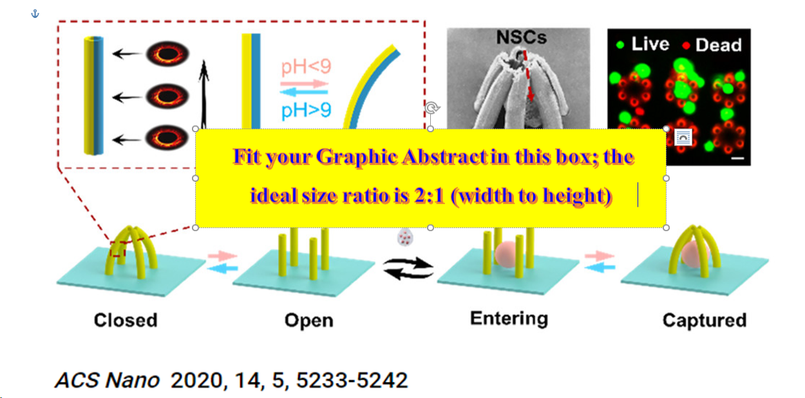
Continuous Size-Dependent Separation of Nanospheres in Human Whole Blood in Microﬂuidic Cascading Spirals
Peter Love ^{1,2}, Getty Petz ³, Steve Gradov ², Otto Gretch ¹*
¹Faculty of Pharmaceutical Sciences, University of British Columbia, Vancouver, BC V6T 1Z3, Canada; otto.gretch@ubc.ca ²TU Dresden, Institute of Fluid Mechanics, Chair of Magnetoﬂuiddynamics, Measuring and Automation Technology, 01062 Dresden, Germany; ³Institut für Biomedizinische Technik und Informatik, Technische Universität Ilmenau, 98693 Ilmenau, Germany
Fluid ﬂow in a curved duct consists of a primary ﬂow directed in the duct’s centerline and a secondary one within the duct’s cross section. The latter consists of the two counter-rotating Dean vortices [1]. The ﬂow of a colloidal suspension through such a duct will size-dependently align the initially homogeneously suspended particles along an equilibrium position close to the inner wall, shown in Figure 1. Microﬂuidic spirals make use of this effect for separating distinct size fractions from a binary ﬂuid in a continuous process [2].
A microﬂuidic device is investigated to separate and thereby concentrate rare components in human whole blood, such as parasites, to facilitate their detection. The device is a polymer cast made of polydimethylsiloxane (PDMS) and due to its low fabrication costs, it is especially advantageous for applications in Africa. Microspheres, suspended in the blood samples in the present investigations substitute the parasites, and vary in their size distribution. A variation of the spirals geometry and the volume rate in the channel inﬂuences the separation dynamics and is investigated experimentally as well as numerically by computational ﬂuid dynamics. The separation process by Dean forces described above can lead to an even higher concentration of the rare component by using a continuous system of two or more spirals in a row.
- de la Vega J, Esquinas PL, Rodriguez-Rodriguez C, Bokharaei M, Moskalev I, Liu D, Saatchi K, Häfeli UO (2019). Radioembolization of Hepatocellular Carcinoma with Built-In Dosimetry: First In Vivo Results with Uniformly-Sized, Biodegradable Microspheres Labeled with 188Re. Theranostics 9, 868-883
- Michaud F, Li N, Plantefeve R, Nosrati Z, Tremblay C, Saatchi K, Moran G, Bigot A, Häfeli UO, Kadoury S, Tang A, Perreault P, Martel S, Soulez G (2019). Selective Embolization with Magnetized Microbeads using Magnetic Resonance Navigation in a Liver Controlled-flow Model. Med Phys 46, 789-799

