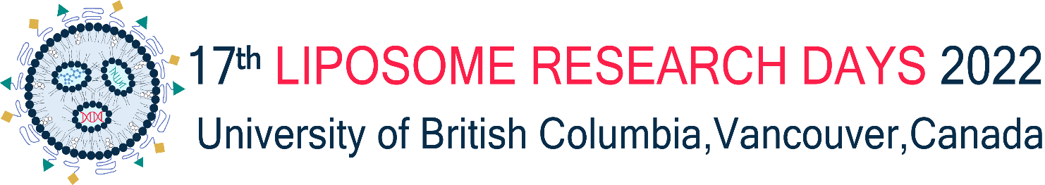

Instructions for abstract submission
17th Liposome Research Days, Catalyzing the Nanomedicine Revolution
June 12-15, 2022, University of British Columbia

- Font: Arial, 12 pt.
- Abstract size is 8.5" x 5.5" (19 cm x 14 cm) with 1 cm margins.
- Title should be in bold letters, capitalized and centered across the page
- Author names are centered and identified with numerical superscripts with the presenting author's name underlined.
- Author affiliations are centered and identified with numerical superscripts that correspond to the respective author's names; include the email address for the presenting author
- Please see below for an example.
TITLE
John B. Author¹ and Suzy Q. Author²
¹Department of Drug Delivery, University of BC, Vancouver Y6M 2X4 (email: jbauthor@ubc.ca) and ²Department of Membrane Biophysics , University of BC, Vancouver Y6G 2M6
Lorem ipsum dolor sit amet, consectetuer adipiscing elit. Phasellus hendrerit. Pellentesque aliquet nibh nec urna. In nisi neque, aliquet vel, dapibus id, mattis vel, nisi. Sed pretium, ligula sollicitudin laoreet viverra, tortor libero sodales leo, eget blandit nunc tortor eu nibh. Nullam mollis. Ut justo. Suspendisse potenti.
Sed egestas, ante et vulputate volutpat, eros pede semper est, vitae luctus metus libero eu augue. Morbi purus libero, faucibus adipiscing, commodo quis, gravida id, est. Sed lectus. Praesent elementum hendrerit tortor. Sed semper lorem at felis. Vestibulum volutpat, lacus a ultrices sagittis, mi neque euismod dui, eu pulvinar nunc sapien ornare nisl. Phasellus pede arcu, dapibus eu, fermentum et, dapibus sed, urna. Morbi interdum mollis sapien. Sed ac risus. Phasellus lacinia, magna a ullamcorper laoreet, lectus arcu pulvinar risus, vitae facilisis libero dolor a purus. Sed vel lacus. Mauris nibh felis, adipiscing varius, adipiscing in, lacinia vel, tellus. Suspendisse ac urna. Etiam pellentesque mauris ut lectus. Nunc tellus ante, mattis eget, gravida vitae, ultricies ac, leo. Integer leo pede, ornare a, lacinia eu, vulputate vel, nisl. Morbi interdum mollis sapien. Sed ac risus. Phasellus lacinia, magna a ullamcorper laoreet, lectus arcu pulvinar risus, vitae facilisis libero dolor a purus. Sed vel lacus. Mauris nibh felis, adipiscing varius, adipiscing in, lacinia vel, tellus. Suspendisse ac urna. Etiam pellentesque mauris ut lectus. Nunc tellus ante, mattis eget, gravida vitae, ultricies ac, leo. Integer leo pede, ornare a, lacinia eu, vulputate vel, nisl. Lorem ipsum dolor sit.

This work was supported by ?????

