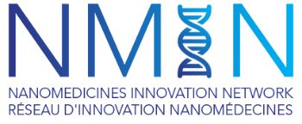
Application

NMIN 2024 Research Conference
Poster Competition
24-27 January 2024 | Vancouver, BC | The Fairmont Waterfront Hotel

Abstract Title:
NMIN Project (if applicable):
Applicant Information:
Applicant Name: | Applicant email:
Supervisor: | Supervisor email:
Position/degree of study: | Institution:
Phone (Cell): | Email:
Address:
City: | Province: | Postal Code:
Have you presented this research previously? No Yes  If yes, where? | Has this abstract been previously published or accepted for publication? No Yes  If yes, where?

Supervisor’s endorsement:

Supervisor Name (Please print) Signature Date
Trainee/HQP Name (Please print) Signature Date

Poster abstracts and completed application forms must be uploaded online to the DropBox Submission Folder (here) no later than Monday 6 November 2023. Applicants will be sent an email confirming receipt.

